Open Coding Analysis Report

**Research Question:** What kind of study strategies students perceive as the best for an introductory computer science course?

**Analysis**

Under the instruction of Professor Liao, we used the open-coding approach as our text analysis method. Through Google Sheet, two authors of this report read the text and computed 22 codes independently (approximately 12% of the whole data set). In order to adjust to the low Cohen’s kappa value from the first round comparison, we decided to replace some specific categories with more generalized categories. For instance, we replaced “go to office hours” and “ask peer” with Seek Help in our final codebook. Another example is replacing “lecture”, “reading”, and “video” with material. After standardizing the codes and discussing the discrepancy between our initial codebooks, we achieved a Cohen’s kappa of 0.89 (kappa=1 after excluding N/A).

The final codebook consists of 7 codes representing which strategy students found most effective in succeeding in the introductory computer science course.

* NA: Not include any strategies or is meaningless.
* Seek help: tutors, office hours, partner, group study, precepts.
* Time management: no procrastination, manage time wisely.
* Prior experience: prior programming background, familiarity with the workload.
* Review: rewatch lecture, redo assignments, doing practice exams.
* Material: pay attention to lectures, readings, and outside resources.
* Classwork: lab, assignments, project.

**Observation**

188 responses in total, 269 codes in total and 234 excluding N/A.

* NA: 35; Excluded in further analysis
* Seek help: 51 (21.8%)
* Time management: 62 (26.5%)
* Prior experience: 42 (17.9%)
* Review: 11 (4.7%)
* Material: 43 (18.4%)
* Classwork: 25 (10.7%)

Time > Seek Help > Material > Experience >> Classwork > Review

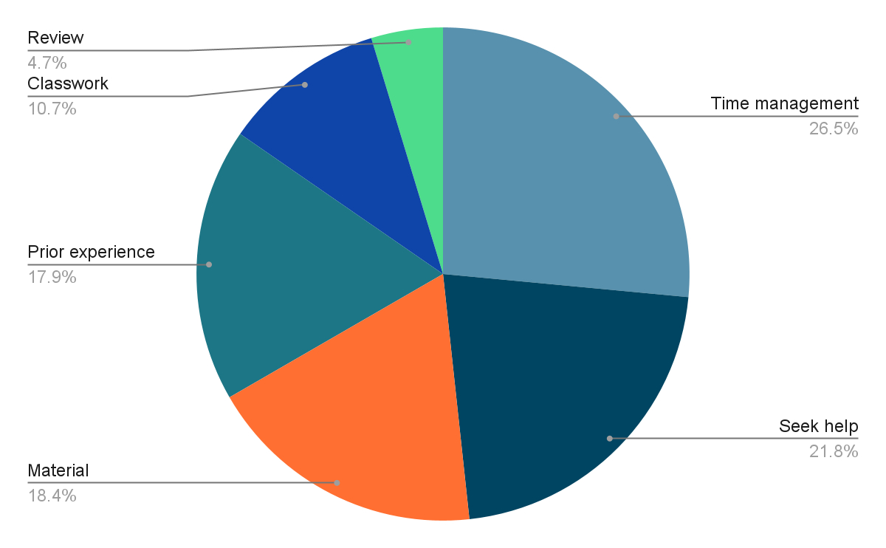

We selected four strategies that the students recommended the most and then observed patterns of these strategies mentioned by the same student at the same time.

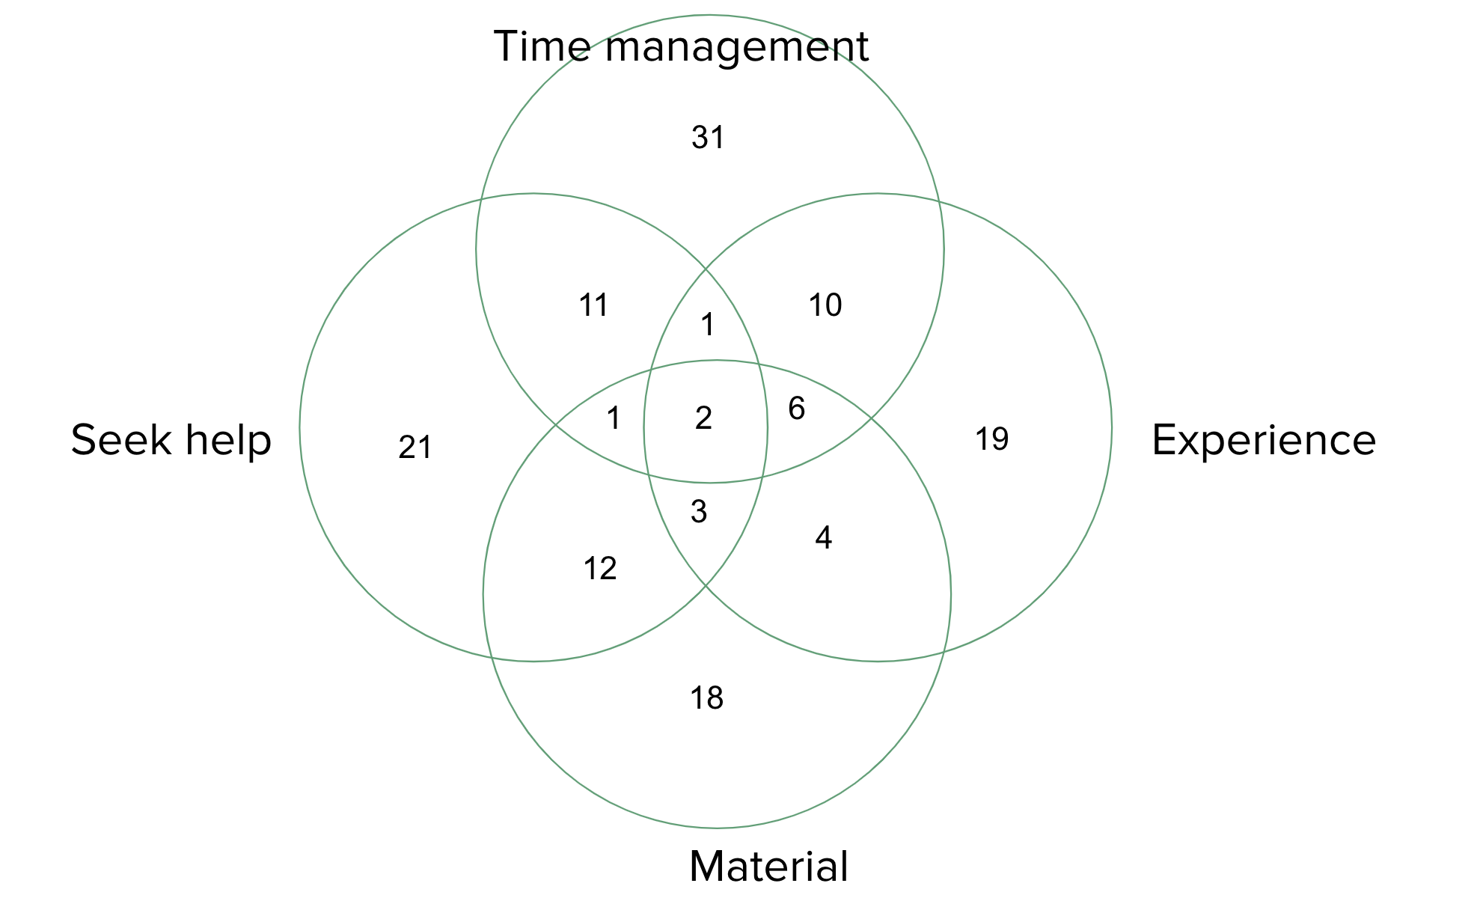

We found that

* 6 students mention BOTH seek help & experience.
* 15 students mention BOTH seek help & time management
* 15 students mention BOTH experience & material.
* 18 students mention BOTH seek help & material.
* 19 students mention BOTH time management & experience.

**Implication**

17.9% of students recommend having some prior experiences before taking the course, which led to a question of whether the course is actually introductory and beginner friendly. To fully understand the material, students would either depend on their prior knowledge or extra help from others. Students start the assignments early so they have enough time to ask questions.

Due to the fact that the data is self-reported, the reliability of the data itself remained questionable. In addition, since we have no information about the student’s actual performance and their background, the correlation between the strategies and its corresponding effectiveness can not be concluded. A follow-up study and experiment would be needed.